Numl university Hyderabad



ASSIGNMENT #3

**Submitted by :- Khadija Abbasi**

**Class :- BSCS-III**

**Subject :- Digital Logic Design**

**Submitted to :- Sir Rafay**

**Date :- 19-Mar-2023**

**Session :- 2023**

**PRACTICAL # 4:**

1. Simplify given expression using Standard Sum of Product, also show step by step process of building a circuit and designing a truth table.
2. **F1(A,B,C) = A’B’C + BC’ + AC’**

**Answer:**

**F1(A,B,C) = A’B’C + BC’ + AC’**

**=A’B’C+(A+A’)BC’+AC(B+B’)**

**= A’B’C + ABC’ +A’BC’ + ABC’ + AB’C’.**

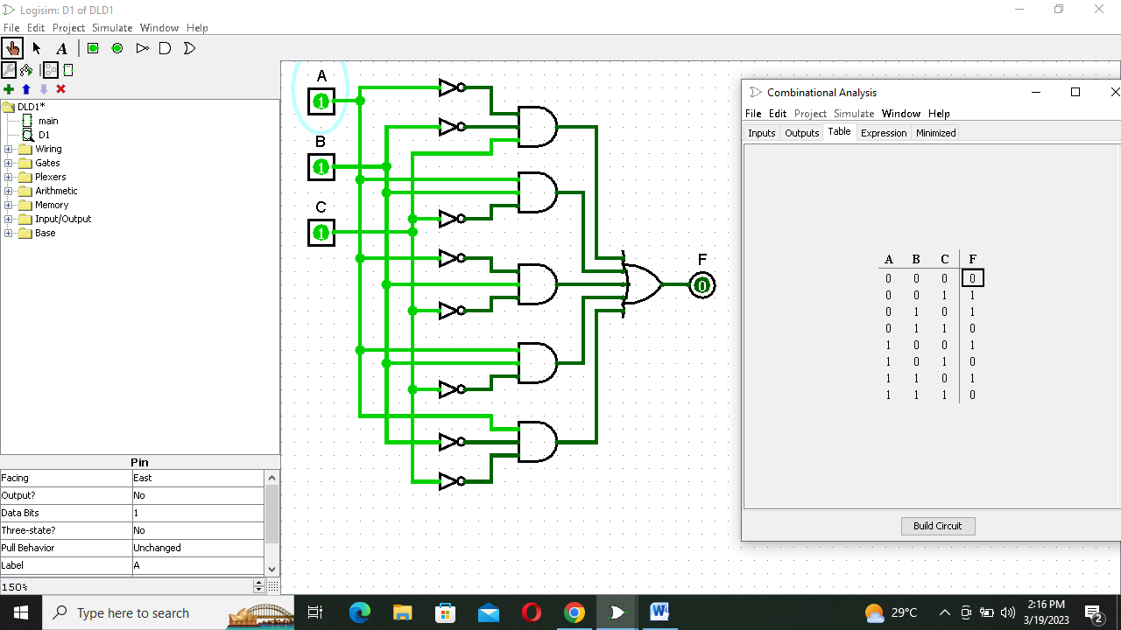

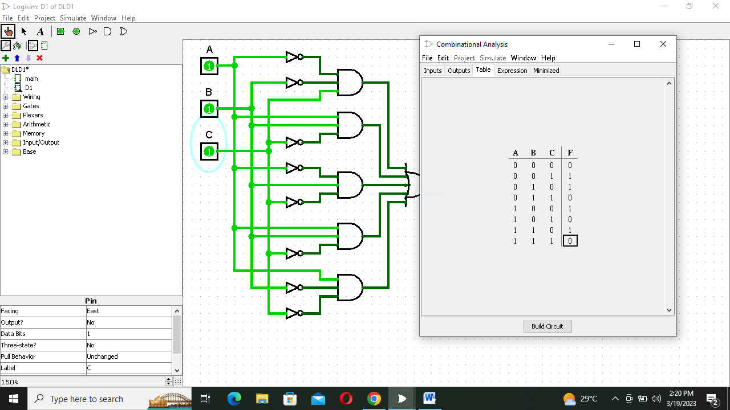

1. **F2(A,B,C) = AB’C’ + AC’ + B’C’**

**Answer.**

**F2(A,B,C) = AB’C’ + AC’ + B’C’**

**= AB’C’ + AC’(B+B’) + B’C’(A+A’)**

**=AB’C’ + ABC’ + AC’B’ + AB’C’ + A’B’C’.**

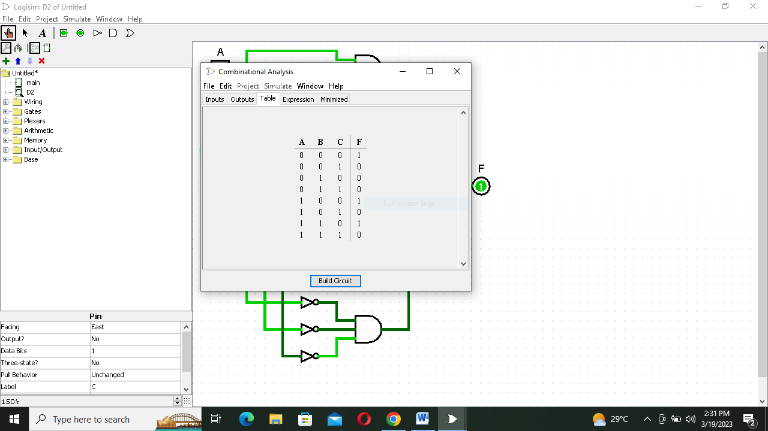

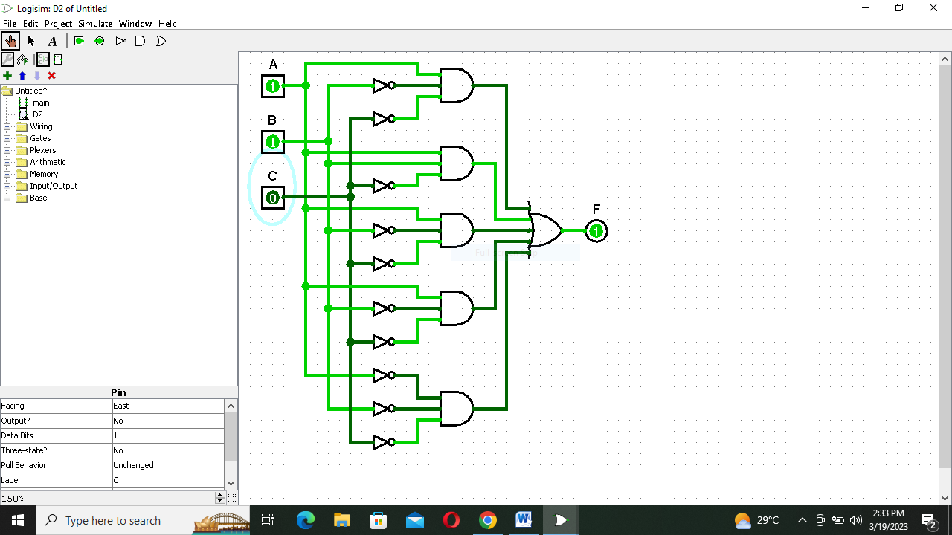

1. **F1(A,B,C,D) = A’B’C’D’ + ABC’ + AC’**

**Answer:**

**F1(A,B,C,D) = A’B’C’D’ + ABC’ + AC’**

**= A’B’C’D’ + ABC’(D+D’) + AC’(B+B’).**

**= A’B’C’D’ + ABC’D + ABC’D’ + ABC’ + AB’C’**

**= A’B’C’D’ + ABC’D + ABC’D’ + ABC’(D+D’) AB’C’(D+D’).**

**= A’B’C’D’ + ABC’D + ABC’D’ + ABC’D + ABC’D’ + AB’C’D + AB’C’D’.**

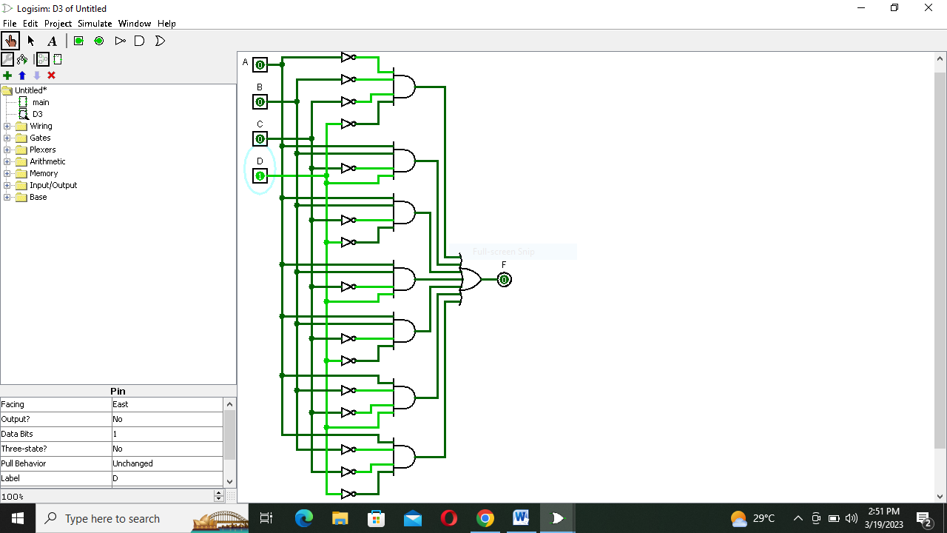

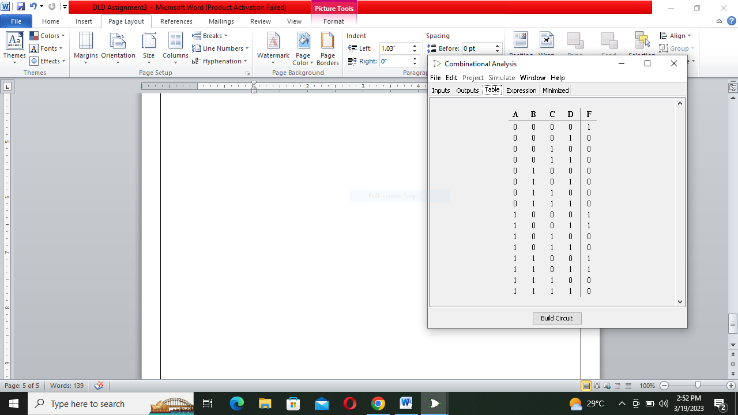

1. Simplify given expression using Standard Product of Sum, also show step by step process of building a circuit and designing a truth table.
2. **F1(A,B,C) = (A’+B’+C )( B+C’) ( A+C’)**

**Answer:**

**F1(A,B,C) = (A’+B’+C )( B+C’) ( A+C’)**

**= (A’+B’+C’)(B+C’+A.A’) (A+C’+B.B’)**

**=(A’+B’+C’)(A+B+C’)(A’+B+C’) (A+B’+C)(A+B’+C’).**

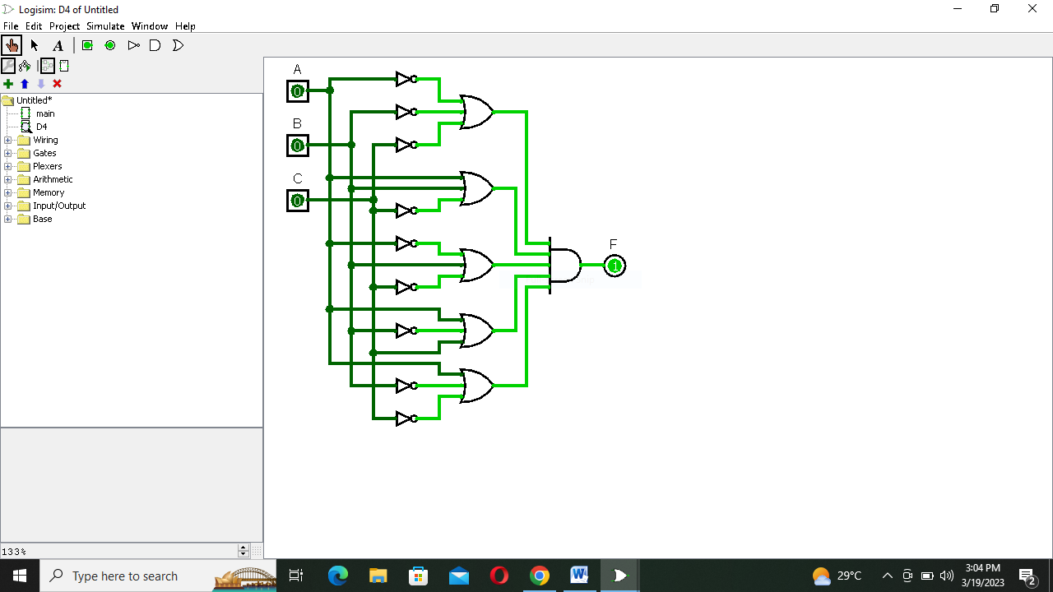

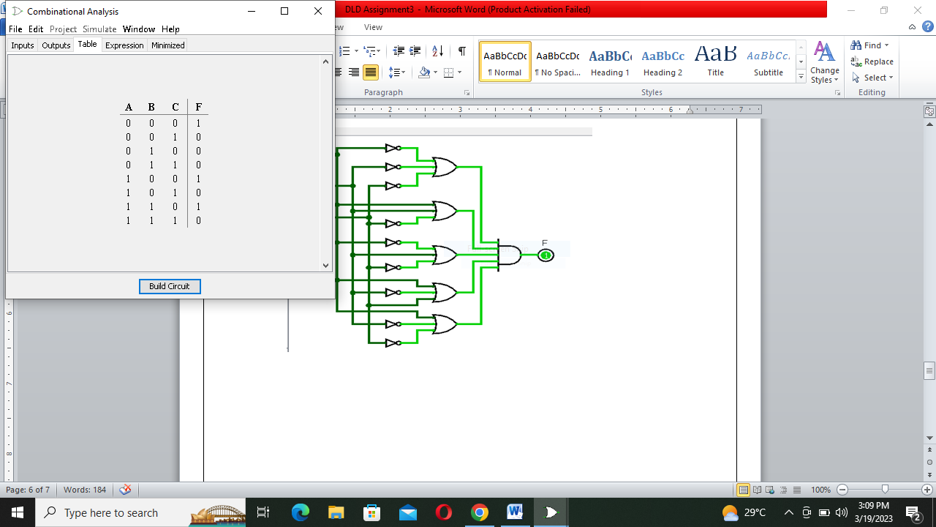

1. **F2(A,B,C) = (A’+B’ )( A+C’) ( B+C’)**

**Answer:**

1. **F2(A,B,C) = (A’+B’ )( A+C’) ( B+C’)**

**= (A’+B’+C.C’)(A+C’+B.B’)(B+C’+A.A’).**

**=(A’+B’+C)(A’+B’+C’)(A+B+C’)(A+B’+C’)(A+B+C’)(A’+B+C’).**

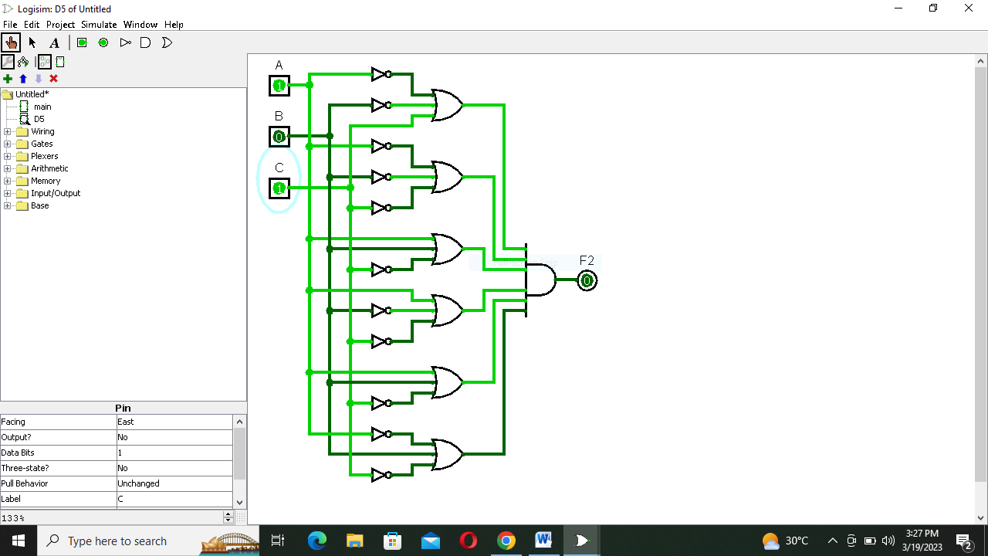

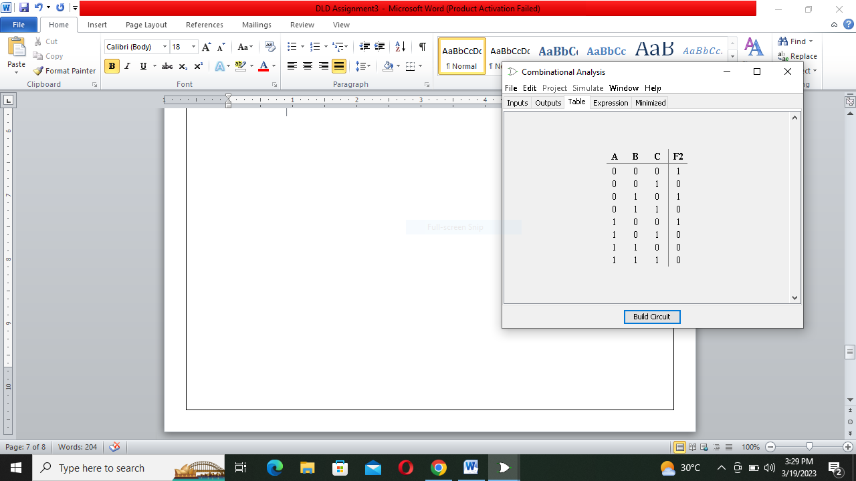

1. **F1(A,B,C,D) = (A’+B’+C+D )( B+C’+D) ( A+C’).**

**Answer:**

**F1(A,B,C,D) = (A’+B’+C+D )( B+C’+D) ( A+C’).**

**= (A’+B’+C+D )( B+C’+D+A.A’) ( A+C’+B.B’).**

**=(A’+B’+C+D)(A+B+C’+D)(A’+B+C’+D)(A+B+C’D.D’)(A+B’+C’+D.D’).**

**=(A’+B’+C+D)(A+B+C’+D)(A’+B+C’+D)(A+B+C’+D)(A+B+C’+D’)(A+B’+C’+D)(A+B’+C’+D’).**

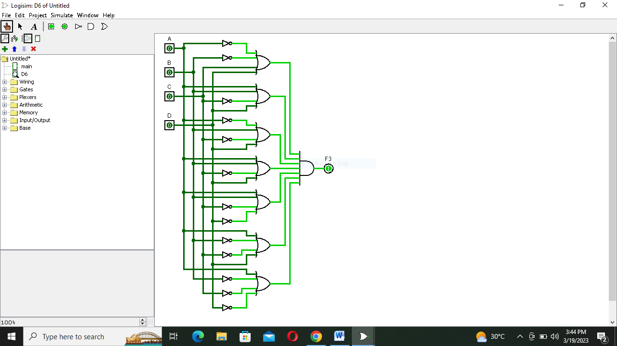

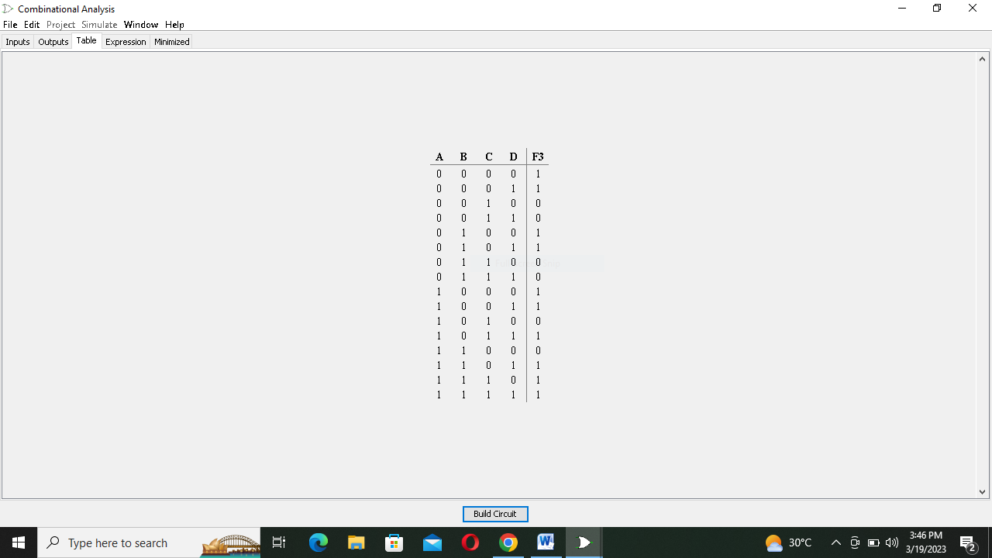

3: Why do we convert SOF & POS into their Canonical form?

Answer:

* Standardization makes the evaluation, simplification, and implementation of Boolean expressions much more systematic and easier.
* We Perform Sum of Product & Product of Sum for converting Truth Table into Logical Expression.

4: What is Combinational Analysis?

Answer:

A subsystem of Logisim called Combinational Analysis can convert between regular logic circuits and their corresponding Boolean expressions and truth tables.

**5:** What are minterms and Maxterms?

Answer:

**Minterms:**

Boolean Functions can be defined by truth tables. In a Boolean function, a product term in which all the variables appear is called a minterm of the function.

Minterms specify the function as an OR of the minterms (product terms).

**Maxterms:**

Boolean Functions can be defined by truth tables. In a Boolean function, a sum term in which all the variables appear is called a maxterm of the function.

Maxterms specify the function as an AND of the maxterms (product terms).

**THE END**